**BOMBO PARENTS NURSERY AND PRIMARY SCHOOL**

**MIDDLE CLASS END OF TERM ONE EXAMINATIONS.**

**MATHEMATICAL CONCEPT**

**My name is ........................................................................................**

**Circle the different number**

|  |  |  |  |  |
| --- | --- | --- | --- | --- |
| 1 | 1 |  | 3 | 1 |
| 2 | 2 |  | 2 | 4 |
| 5 | 3 |  | 3 | 3 |
| 4 | 7 | | 4 | 4 |
| 5 | 5 | | 3 | 5 |
| 2 | 4 | | 4 | 4 |

**Match the same numbers.**

3 0

5 4

2 3

0 5

4 2

1 1

**Match and colour shapes**

**Colour the number**

**5 =**

**3 =**

**1 =**

**4 =**

**Count and write.**

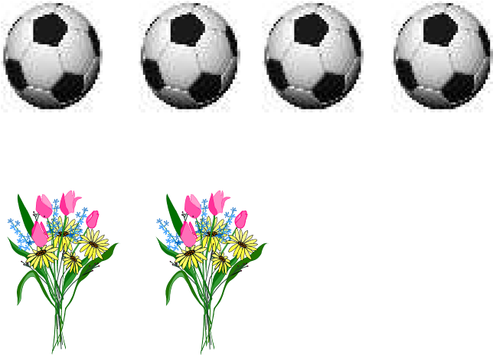 =___________________

=_______________________

___________________

=

______________

=

**“GOOD LUCK”**

**BOMBO PARENTS NURSERY AND PRIMARY SCHOOL**

**MIDDLE CLASS END OF TERM ONE EXAMINATIONS.**

**ENGLISH**

**My name is........................................................................................**

**Matching to the belonging.**

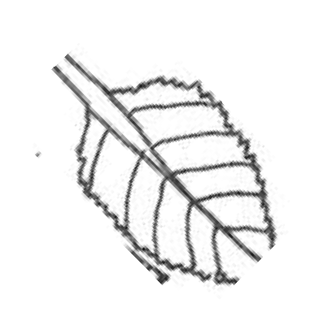 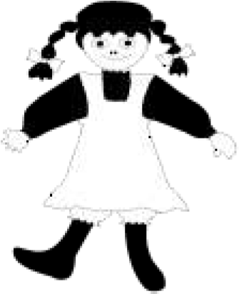

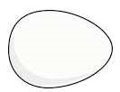 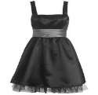

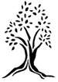 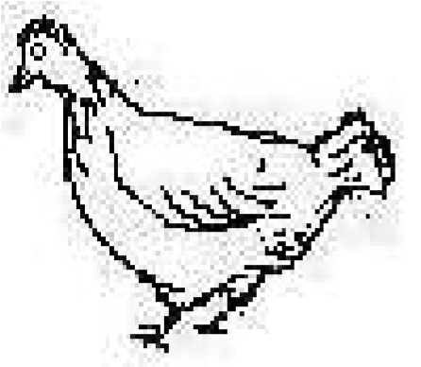

1. Complete the pictures.

|  |  |  |  |  |  |
| --- | --- | --- | --- | --- | --- |
|  |  |  |  |  |  |
|

1. Match pictures to words.

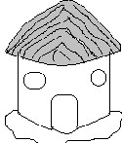sun

hut

pot

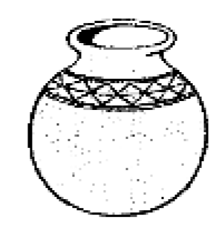

bat

boy

**Circle the same word**

mat

mat

pot

boy

sun

girl

pen

sun

axe

axe

ant

bag

**Underline the odd word out**

* book cup book book

__________________________________________________

* girl apple apple apple

__________________________________________________

* leaf leaf boy leaf

__________________________________________________

* tree tin tin tin

__________________________________________________

* egg egg egg bed

__________________________________________________

**Tick the correct word**

-

mat

man

-

bell

bed

-

cat

cow

-

pan

pot

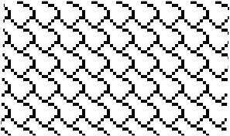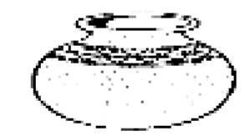

***“ Success”***

**BOMBO PARENTS NURSERY AND PRIMARY SCHOOL**

**MIDDLE CLASS END OF TERM ONE EXAMINATIONS.**

**READING**

**My name is........................................................................................**



**Copy the same sounds.**

|  |  |  |  |  |  |
| --- | --- | --- | --- | --- | --- |
| **s** | **a** | **t** | **i** | **p** | **n** |
|  |  |  |  |  |  |

**Match sound to pictures.**

e

h

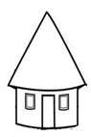

k

m

c

**Circle the same sounds.**

**a a s i t i**

**n p p m m o r e r**

**Name the pictures.**

________________________________________

__________________________________________



***“SUCCESS”***

**BOMBO PARENTS NURSERY AND PRIMARY SCHOOL**

**MIDDLE CLASS END OF TERM ONE EXAMINATIONS.**

**HEALTH HABITS**

**My name is........................................................................................**

**I can copy and draw.**

|  |  |  |  |  |  |
| --- | --- | --- | --- | --- | --- |
| head | eye | ear | tongue | nose | leg |
| head |  |  |  |  |  |

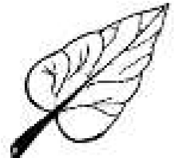

**I can match the belonging.**

**.**

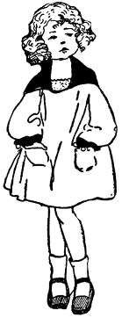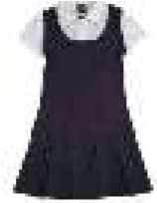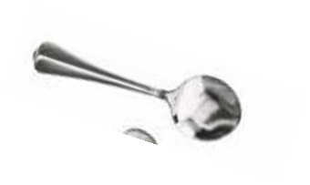

**I can match a picture to a word**

brother

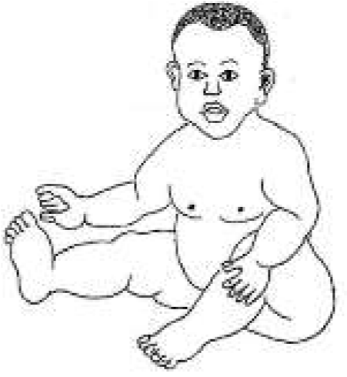

mother

baby

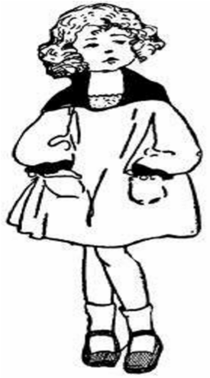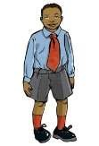

sister

**Oral**

Which school do you go to?

Who are your teachers?

How many days make a week?

**Do the actions.**

Sit down

Clap your hands

Close the door

**Copy and write.**

m m m m m m m

mat man moon map

***“Always doors for success are open”***

**BOMBO PARENTS NURSERY AND PRIMARY SCHOOL**

**MIDDLE CLASS END OF TERM ONE EXAMINATIONS.**

**SOCIAL DEVELOPMENT**

**My name is........................................................................................**

# Match the same words.

rake knife

basket panga

hoe axe

panga rake

axe hoe

knife basket

# Draw and copy.

|  |  |  |  |
| --- | --- | --- | --- |
|  |  |  |  |
| mosque | church | school | Hospital |
|  |  |  |  |
|  |  |  |  |

# Write the picture number.

2

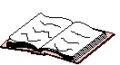 1

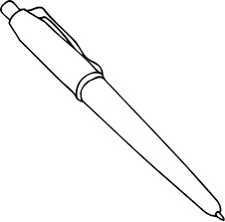

3

5

book _____ pen_____ chair_____ tin______ ball_____

# Colour me please.

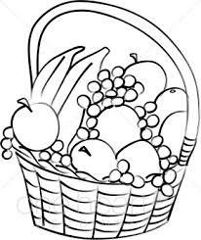

***__ Happy Holidays _***